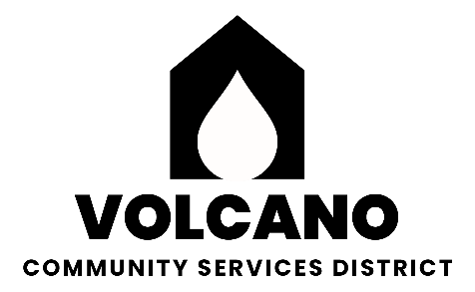

**Volcano Community Services District**

P.O. Box 72

Volcano, California 95689

**BOARD OF DIRECTORS**

REBECCA KOREMATSU (209)296-1995

PRESIDENT MIKE SORENSEN (209)296-7664

VICE PRESIDENT JOE WOLFBRANDT (209) 712-4251

ALAN KOREMATSU (916)844-9123

PETER SUDEN (209) 304-6313

### **AGENDA**

##### General Meeting

#### **Thursday, May 15, 2025, 2025 •Armory Hall, Volcano • 7:00 P.M.**

In compliance with the Americans with Disabilities Act, if you are a disabled person and you need a disability related modification or accommodation to participate in this meeting, please contact Mike Sorensen at (209)296-7664. Requests must be made as early as possible and at least one-full business day before the start of the meeting. Floor discussion at board discretion will be limited to 5 minutes per subject per individual.

**CONSENT AGENDA:** Items on the consent agenda are considered routine and may be enacted by one motion. Any item may be removed for discussion and made part of the regular agenda under Agenda items at the request of a Board Member.

1. Minutes of the regular meeting of April 10, 2025

**MEETING CALLED TO ORDER:** Minutes of regular meetings are recorded on the Secretary’s computer.

**DISTRICT ENGINEER’S REPORT-** George Barnes

1. Monthly Cleveland Tunnel flow treated and untreated including diverted via black pipe.
2. Review of completed testing results for the current quarter.
3. Waterboard correspondence April 25, 2025: Cross-connection Control Plan due July 1, 2025; status of completion.
4. PFAS sampling.
5. Build weir outside Cleveland Tunnel, D. Ketron and S. Schippers volunteering to help. Update on schedule to have the weir done.
6. Status of ordering/installing extra meters to standardize meters throughout the district.
7. Tree removal near tank.
8. M. Gottstein request: Clarification needed from DE as to the prior decision on Emergency Fire Suppression Release of Water from Redwood Tank and Cleveland Tunnel documentation of valves.
9. Any other issues, etc. to address.

**REGULAR AGENDA**

1. Town bathrooms defensible space. A. Korematsu **ACTION**
2. Water Billing Payment late fee review. R. Korematsu **ACTION**
3. Demand Request. R. Korematsu **ACTION**
4. Renting chairs and tables. B. Stein/A. Korematsu. **ACTION**
5. Secretary’s Report – R. Korematsu Information. Form 700, Board Compensation Report to SCO, demand request, status of billing hand-off and GM position.
6. Meter Reading/Park – R. Zehender Information
7. Hall/Park Grant Report – B. Stein. Information
8. Hearing from those who wish to address the Board (limited to 3 minutes per person). Any person may address the Board at this time upon any subject within the jurisdiction of the Volcano Community Services District. Any matter that requires an action will be referred to the Board for a report and action at a subsequent Board Meeting.
9. Delinquent Account Collections Process and Next Steps. M. Sorensen, R. Korematsu. **ACTION (closed session)**